**DSCI 560 - Lab 1**

|  |  |
| --- | --- |
| Name | Pratham Solanki |
| USC ID | 3242692358 |
| Email | [pdsolank@usc.edu](mailto:pdsolank@usc.edu) |

1. **Installation and Setup**

1.1 **VMware installed**

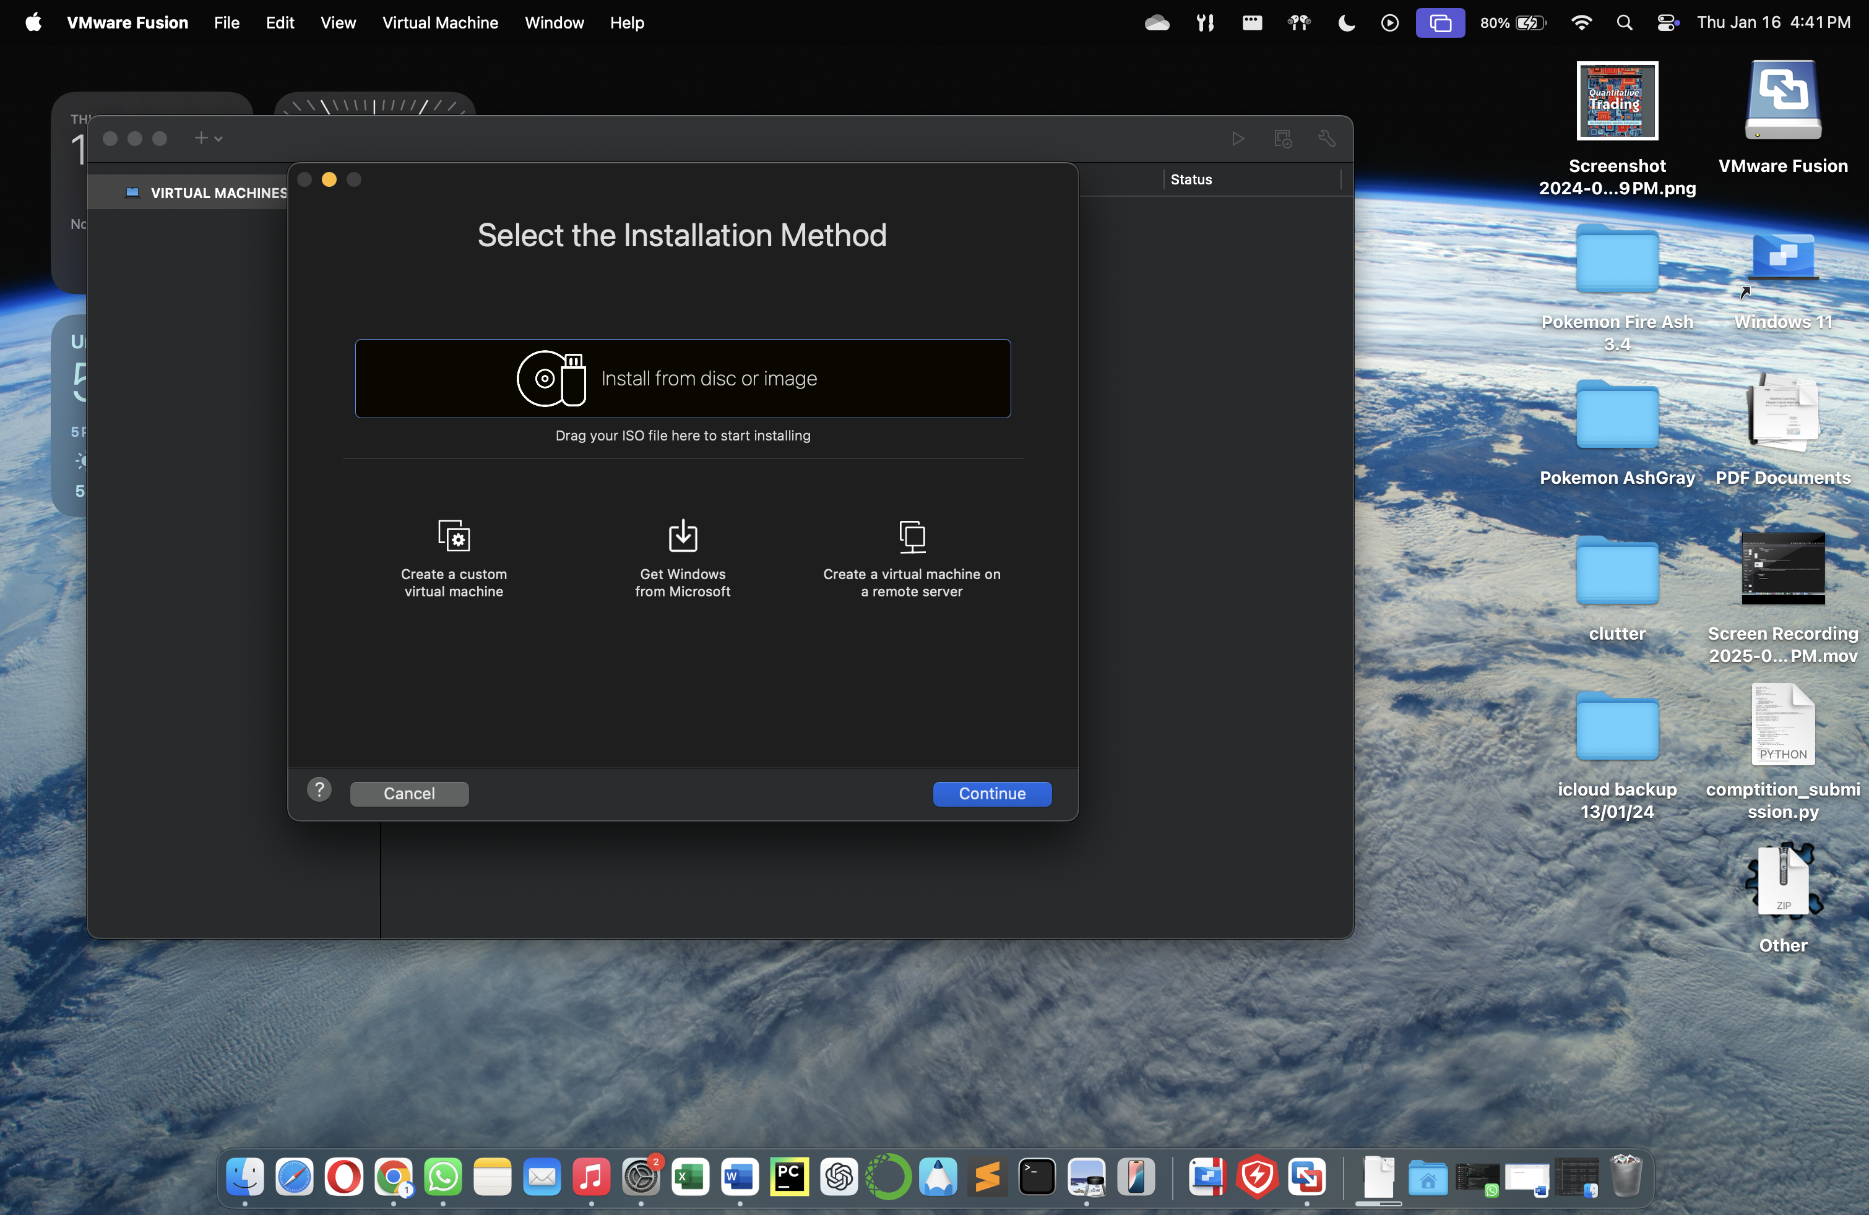

1.2 **Virtual machine (Ubuntu) installed**

* Memory : 4 GB
* Disk space : 20 GB

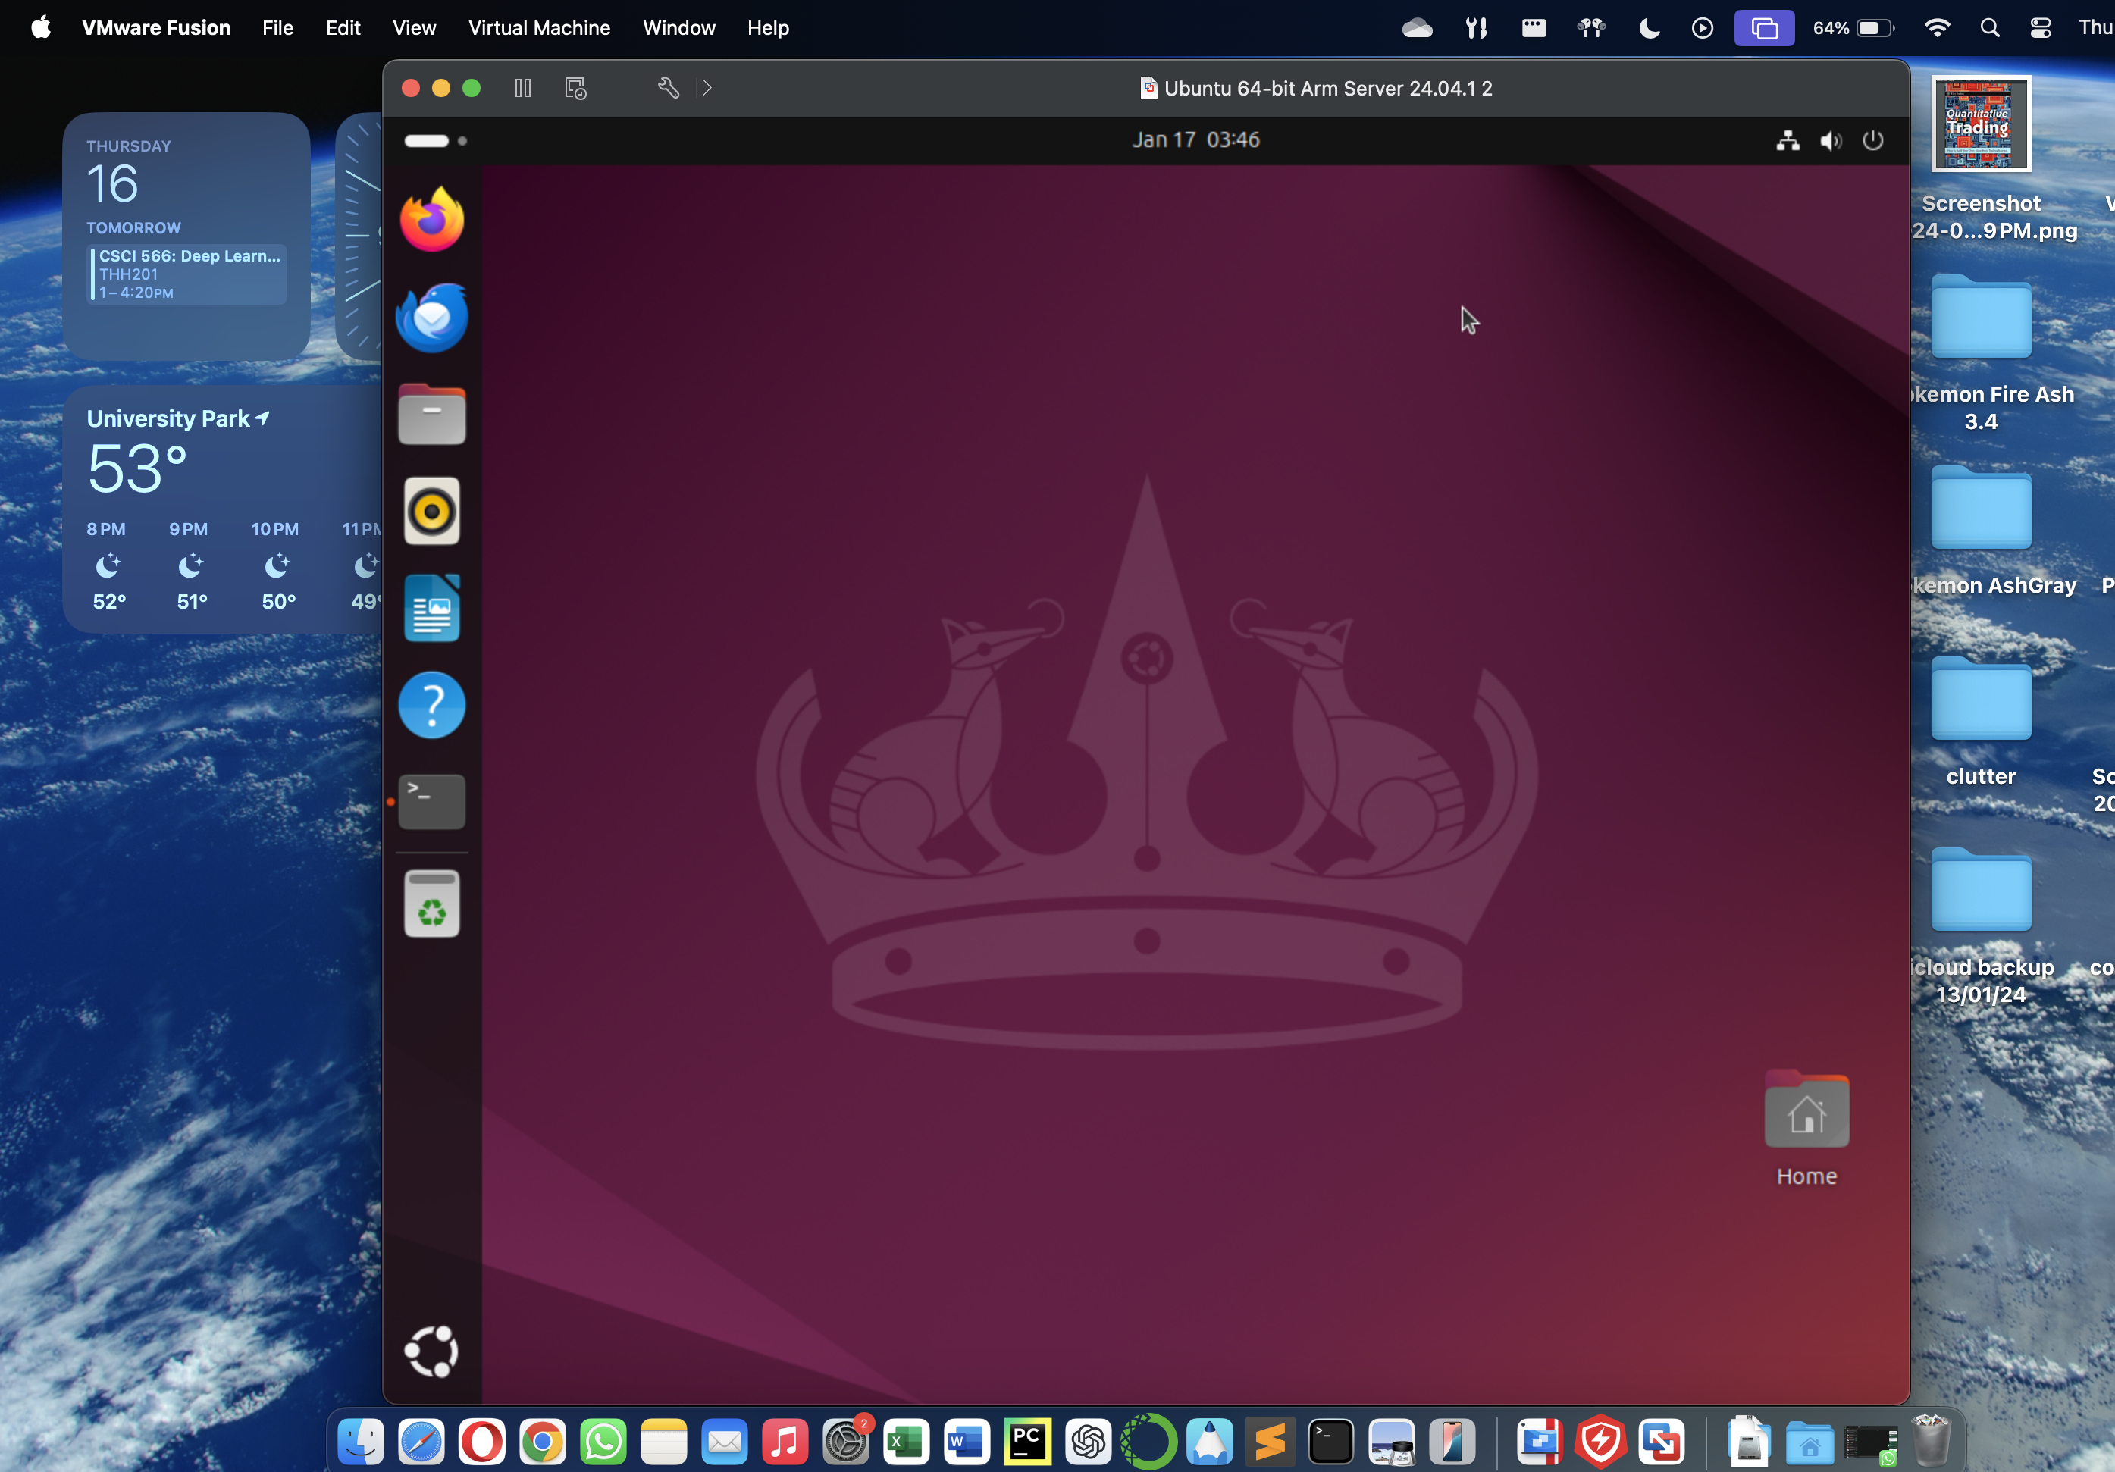

1.3 **Python Installed on Linux**

* Updated the local packages using “sudo apt update”
* Installed python version 3.12.3



* Installed pip version 24.0

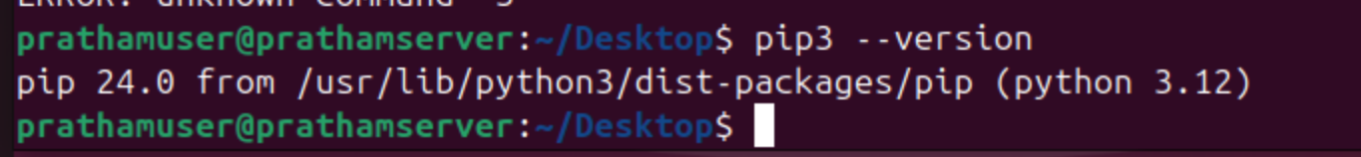

2. **Get Familiar with Linux and Python**

2.1 **Playing around with Linux Terminal**

* Created directory “prathamsolanki-3242692358” and subdirectories “data” and “scripts” using mkdir command
* Created empty python file “task1.py” using touch command

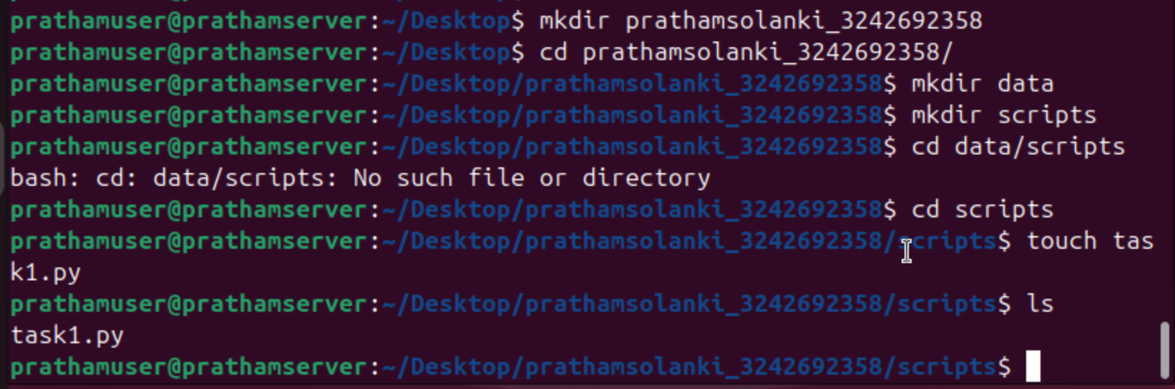

2.2 **A basic Python Script**

* Created the basic python script which greets the user with “Hello,<name>”

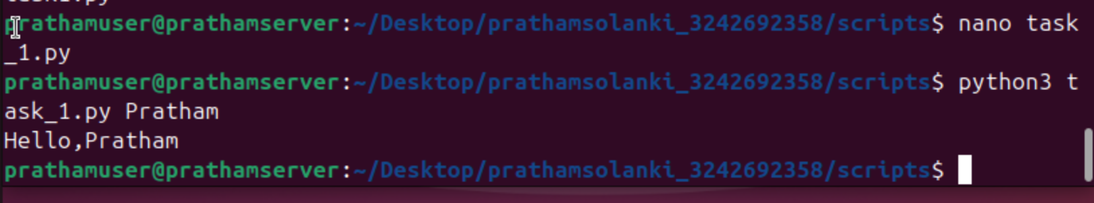

**2.3 Python Web scraping Task**

* Created web_scraper.py file



* Installed requests, beautifulsoup4

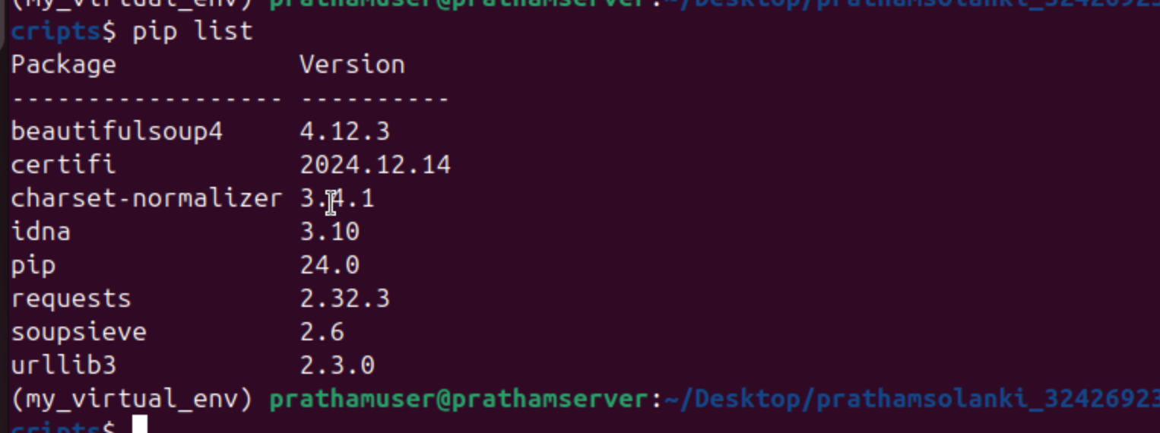

* Created two sub directories in “data” called “raw_data” and “processed_data”

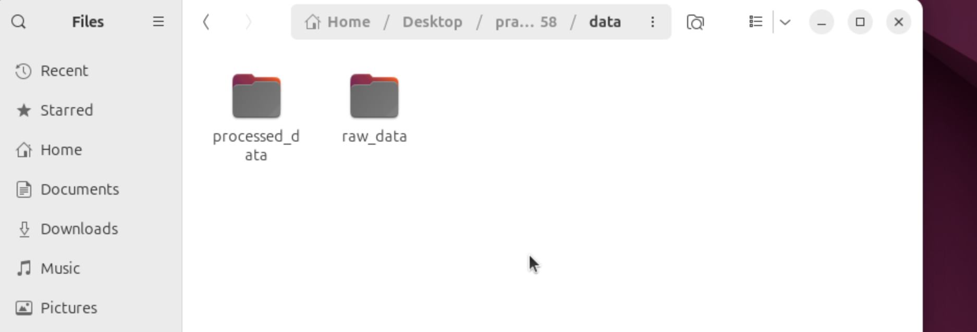

* Printed first 10 lines of the html file created using head command

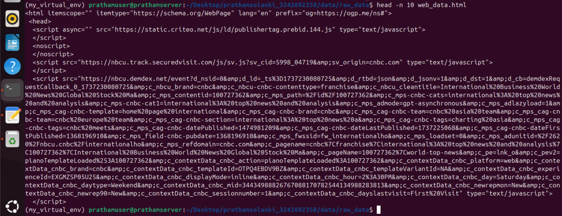

* Web_scraper.py Code:

from selenium import webdriver

import time

from selenium.webdriver.firefox.service import Service

from selenium.webdriver.firefox.options import Options

from bs4 import BeautifulSoup

destination_file_path = '/home/prathamuser/Desktop/prathamsolanki_3242692358/data/raw_data/web_data.html'

gecko_driver_path = '/snap/bin/firefox.geckodriver'

options = Options()

#options.add_argument("--headless")

#options.add_argument("--disable-gpu")

options.add_argument("--window-size=1920,1080")

service = Service(executable_path=gecko_driver_path)

driver = webdriver.Firefox(service=service, options=options)

try:

driver.get("https://www.cnbc.com/world/?region=world")

driver.implicitly_wait(20)

time.sleep(10)

html_content = driver.page_source

html_parsed = BeautifulSoup(html_content,'html.parser')

with open(destination_file_path, "w", encoding="utf-8") as file:

file.write(html_parsed.prettify())

print("Successfully written HTML contents of CNBC home page to web_data.html")

finally:

driver.quit()

* Output:



* Screenshot of output file web_data.html:

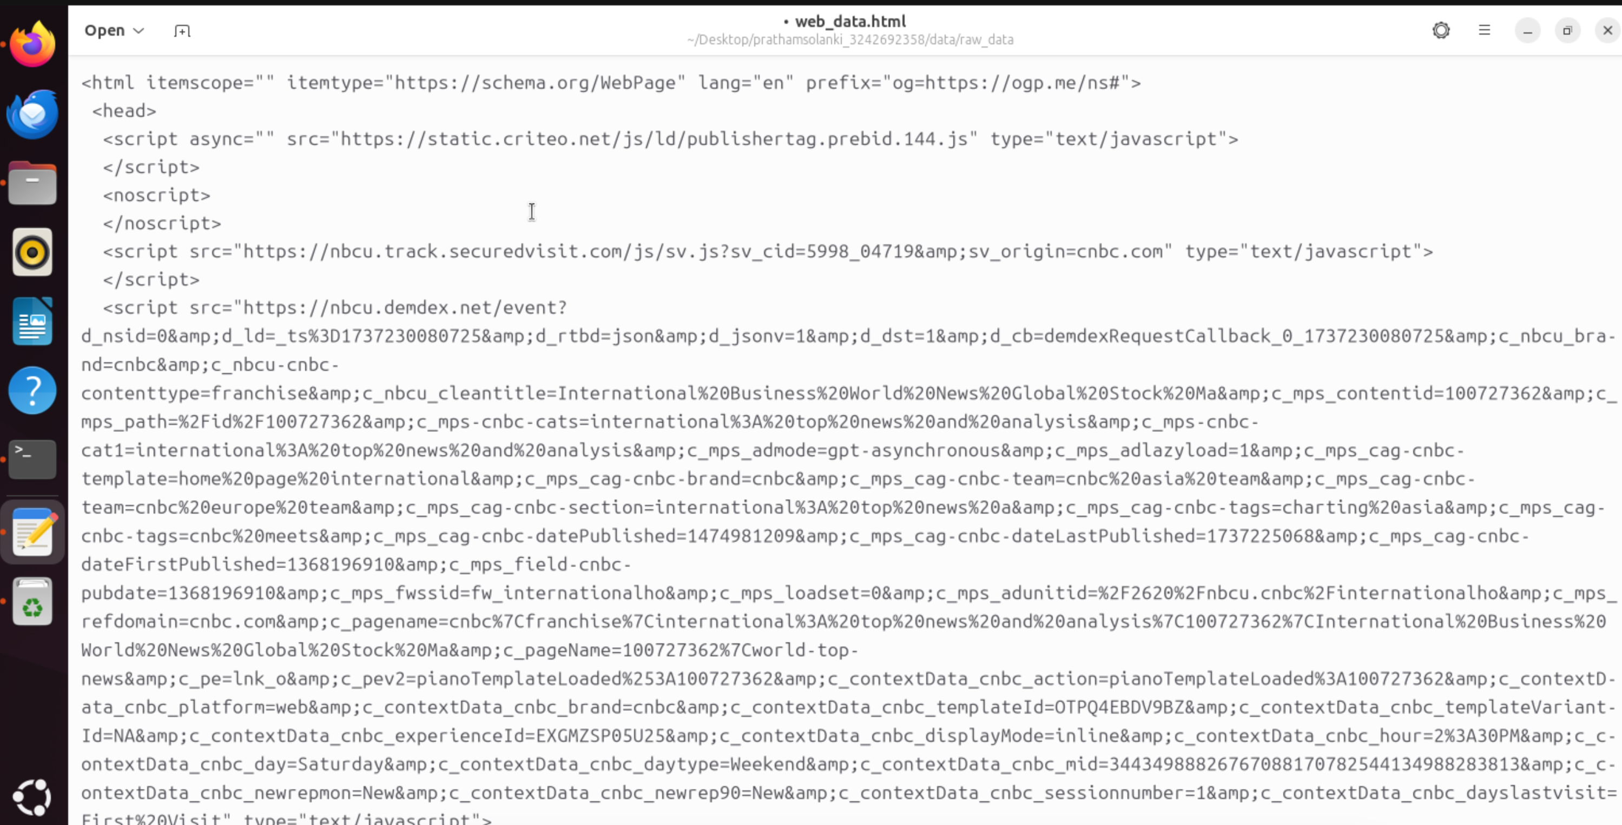

2.4 **Data Filtering Task**

* Created data_filter.py

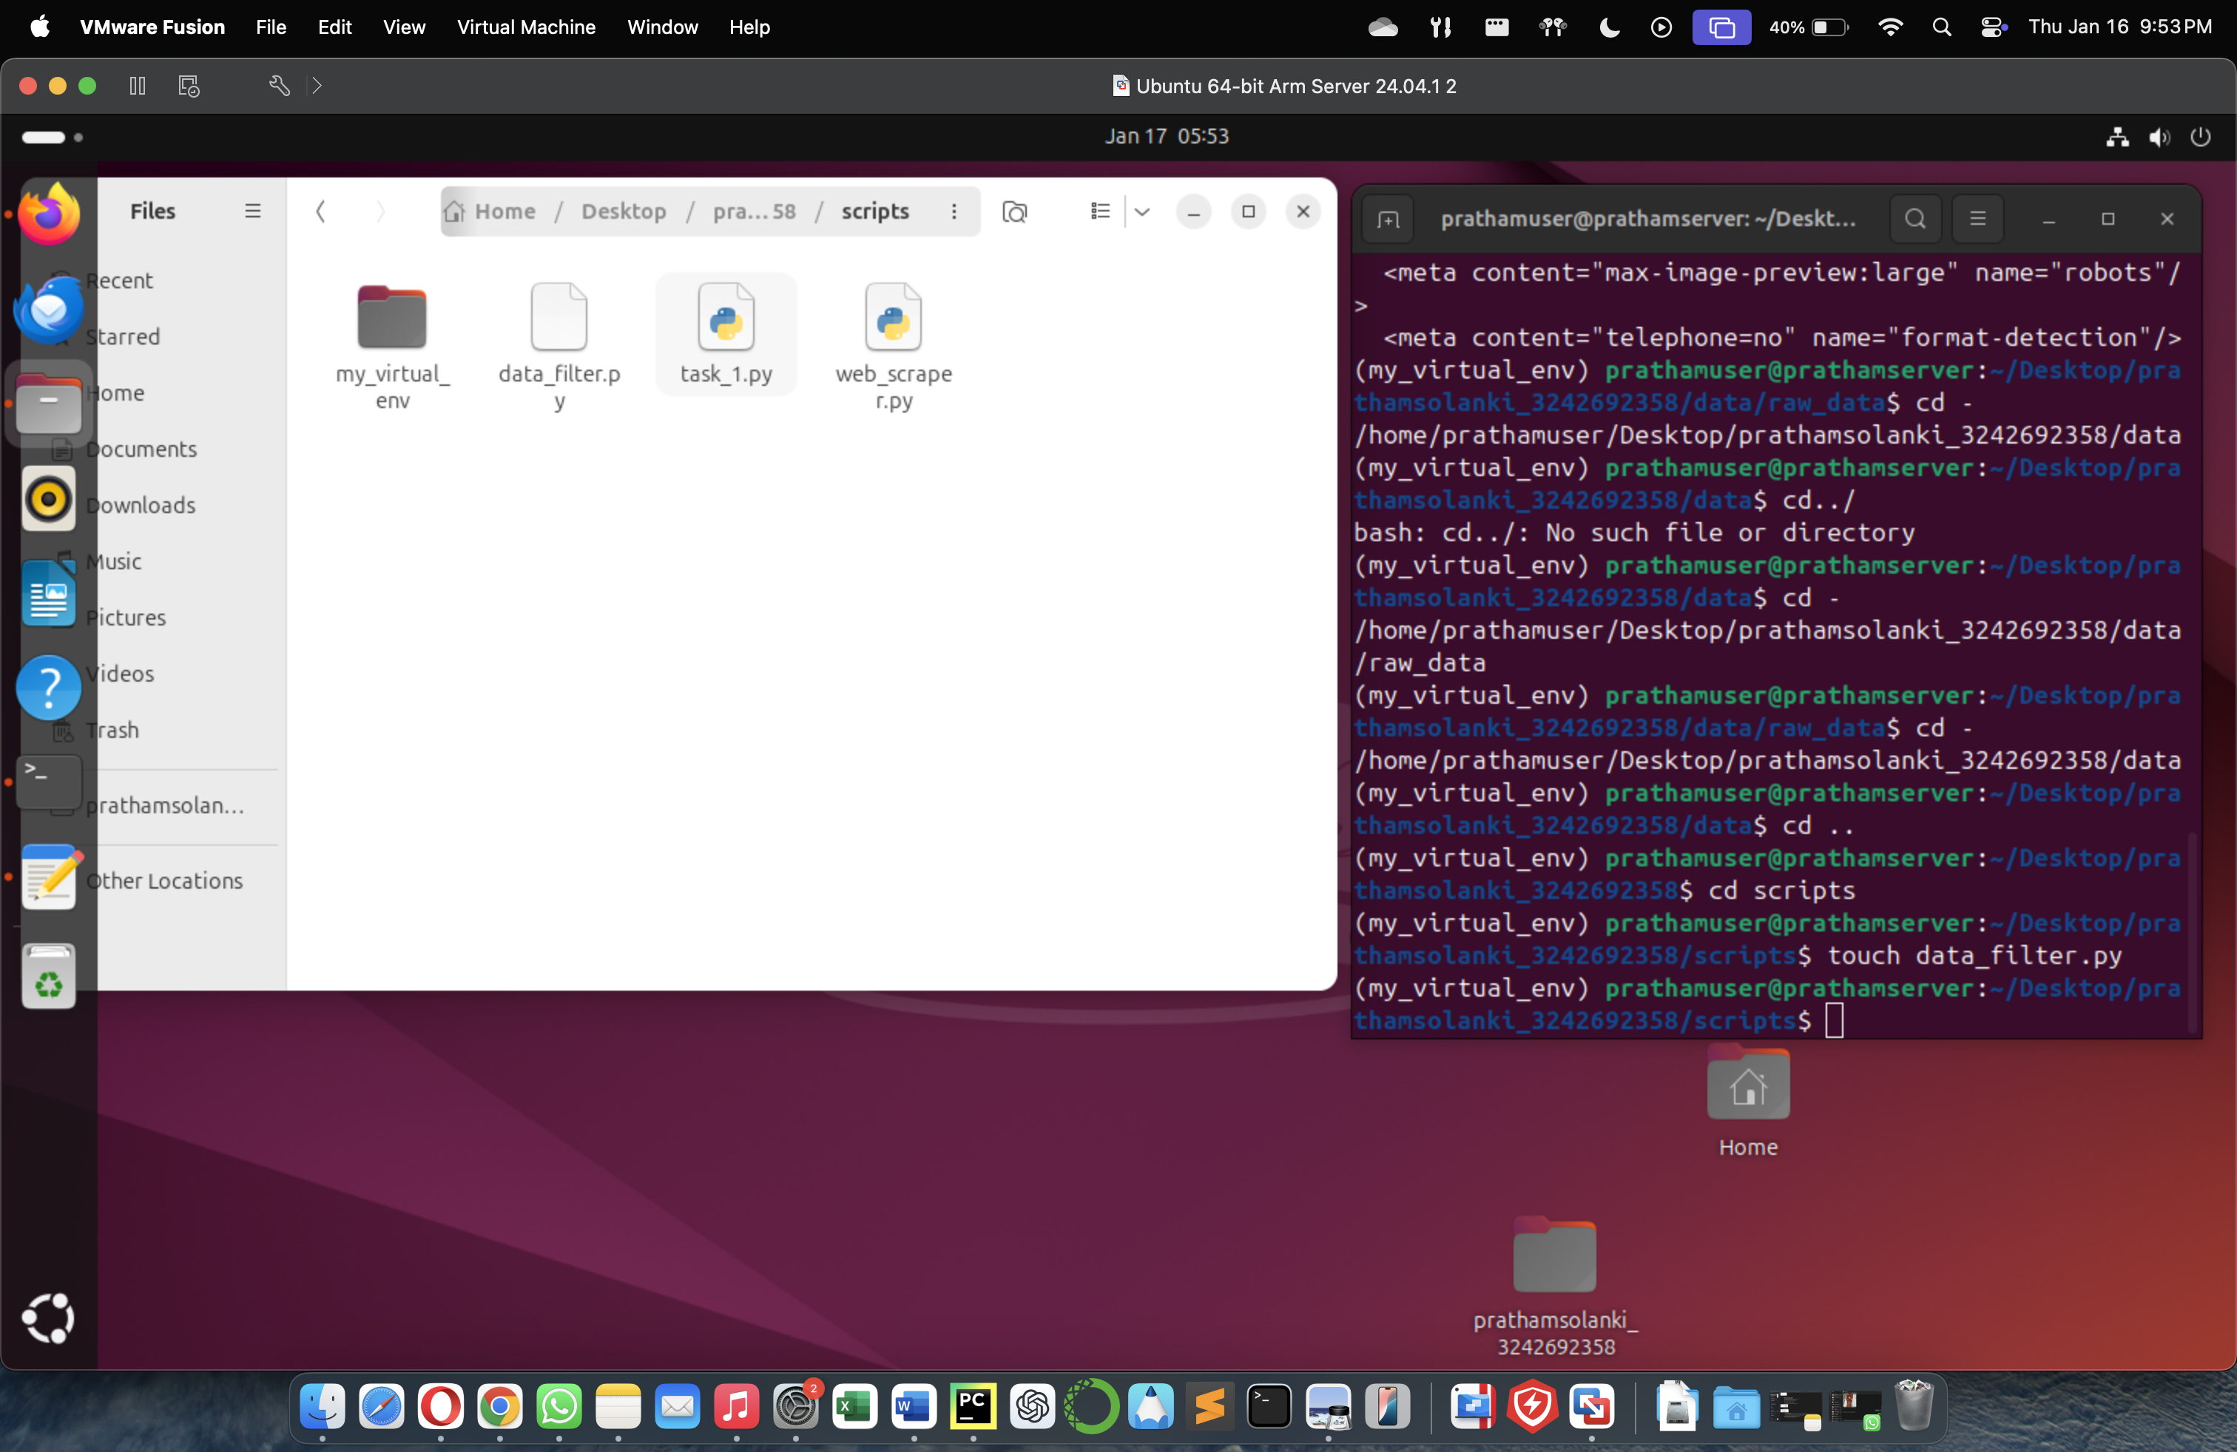

* data_filter.py Code:

from selenium import webdriver

import time

from selenium.webdriver.firefox.service import Service

from selenium.webdriver.firefox.options import Options

from bs4 import BeautifulSoup

destination_file_path = '/home/prathamuser/Desktop/prathamsolanki_3242692358/data/raw_data/web_data.html'

gecko_driver_path = '/snap/bin/firefox.geckodriver'

options = Options()

#options.add_argument("--headless")

#options.add_argument("--disable-gpu")

options.add_argument("--window-size=1920,1080")

service = Service(executable_path=gecko_driver_path)

driver = webdriver.Firefox(service=service, options=options)

try:

driver.get("https://www.cnbc.com/world/?region=world")

driver.implicitly_wait(20)

time.sleep(10)

html_content = driver.page_source

html_parsed = BeautifulSoup(html_content,'html.parser')

with open(destination_file_path, "w", encoding="utf-8") as file:

file.write(html_parsed.prettify())

print("Successfully written HTML contents of CNBC home page to web_data.html")

finally:

driver.quit()

* Output:



* Screenshot of market_data.csv

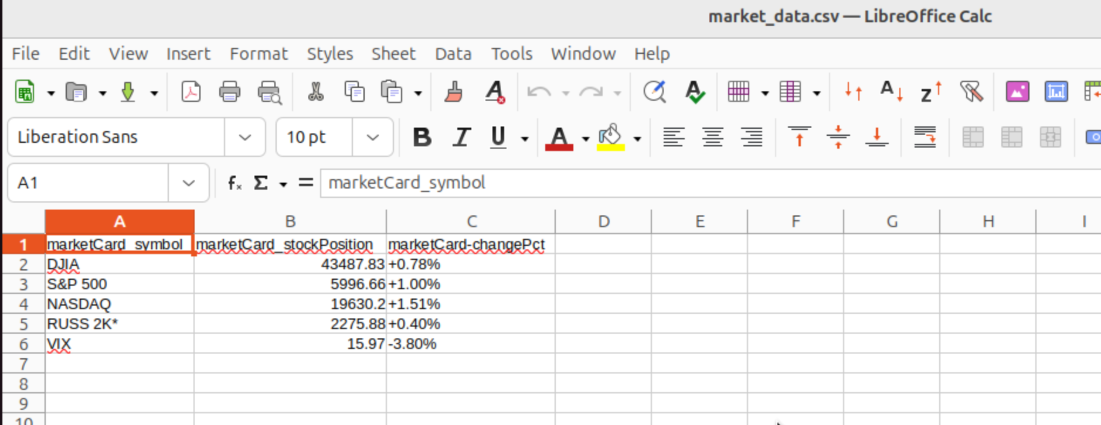

* Screenshot of news_data.csv

